**Animation Project Review Checklist**

James Pratt Graham Vickers

Midterm Client Project

**Concept**

The main purpose of this webpage with animations is to draw attention and awareness to the TRAA. The idea of this page can create a bond between user and the TRAA. With this bond being created, users are more likely to engage with the TRAA through donations and volunteering.

**Schedule**

The schedule for this project revolved completely around the first half of this semester. Most updates to this page were completed on weekends and Fridays due to class time and personal lives. The budget for this project was $0, as the assets were provided by the school.

**Resources**

The required resources for this project are very asset heavy. The largest portion of this website are copy and photographs. After we have the main assets, we need an adobe suite to craft wireframes and designs.

**Research**

The research we did to find a design we liked, revolved around looking at other websites with the same aesthetic, as well as, design videos.

* <https://bestbassfishinglures.com/>
* <https://www.bassresource.com/>
* <https://www.ofah.org/membership/club-membership/>

**Story / Sketches**

See wireframes / design PSDs

**Story Boards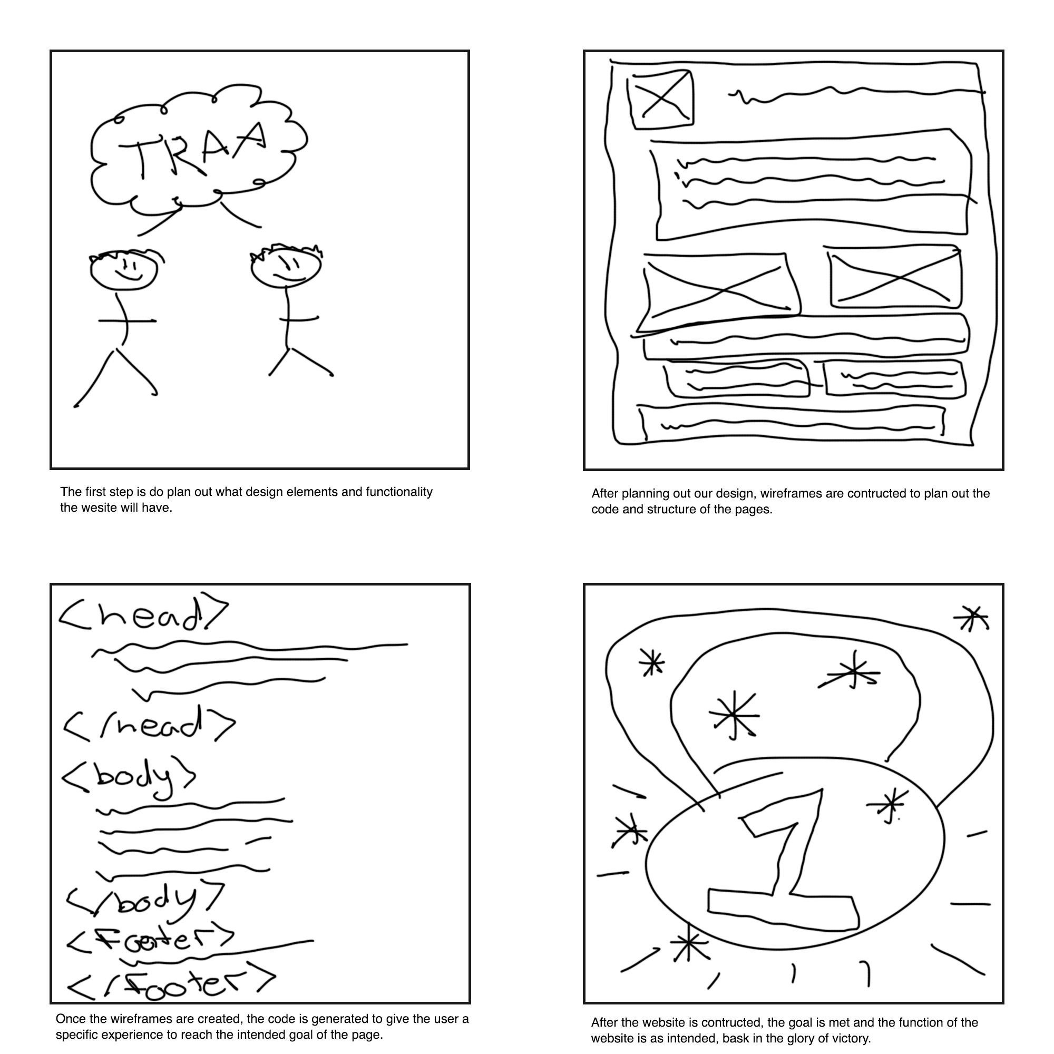­­**

**Script**

N/A

**Production / Editing / Post-Production / Output**

The production of this project starts with brainstorming. As a partnership, we started by inspecting the previous website, looking for potential fixes and improvements. After getting a baseline idea of the function and purpose of our new website, we started wireframing possible pages and ideas. With a narrowed idea of wireframes, we designed starter pages to get a feel for the pages on their own. After designing the pages with specific elements, we started coding the pages. After the base code was manufactured, we tweaked our webpage to a larger width to create a deeper connection between user and TRAA. This is where we stand now.